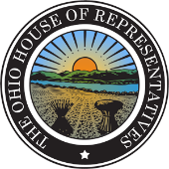
Glenn W. Holmes
Committees:
State & Local Government, Ranking Member
Insurance
Federalism and Interstate Relations
Statehouse:
Office: (614) 466-3488
FAX: (614) 719-3965
Toll Free: 1-800-282-0253
Rep63@OhioHouse.gov
State Representative
63rd House District
June 7, 2018

Kara Ellis
111 Huntington Avenue, Suite 1800
Boston, MA 02199

Dear Ms. Ellis,

We appreciate the investment Steward Healthcare Systems has made to the Mahoning Valley. Having a quality healthcare provider is essential to establishing health community. It is our understanding this is Steward Healthcare System’s intentions.

It has come to my attention that Northside Hospital (owned by Steward Healthcare) and Youngstown General Duty Nurses Association are having contract negotiations. There is a prevalent thought that the negotiations are going extremely slow. Northside Hospital’s staff has experienced a number of changes in protocol that has put patients care at risk.

Additionally, these changes are at the center of negotiations and could become a way to force the nurses into potentially working without a contract. Contract protections, good working conditions and the tools necessary to provide quality patient care are the building blocks to incentivize dedicated service. Steward Healthcare thrives, its employees thrive and the community benefits from quality healthcare, establishing the framework to deliver quality service is critical.

I recognize the commitment of the Youngstown General Duty Nurses Association and the Ohio Nurses Association from the 50 plus years of proud union history caring for the citizens of Mahoning and Trumbull counties, working together encourages the creation of policies that benefit you, the nurses and the Mahoning Valley.

If I can be of assistance, please do not hesitate to contact my office. As an elected official, I need to know the thoughts of those we are elected to represent, so that we may best serve the people.

Sincerely,

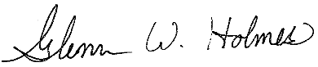

Glenn W. Holmes

